1. Write a single ansible playbook which will install apache and nginx.

2) Ansible playbook to create 10 different directories with minimal code and directory names should be passed as variables.

---

- name: create directories

  hosts: all

  become: yes

  vars:

    directory_names:

      - dir1

      - dir2

      - dir3

      - dir4

      - dir5

      - dir6

      - dir7

      - dir8

      - dir9

      - dir10

  tasks:

    - name: Create directory

      file:

        path: /opt/{{ item }}

        state: directory

        mode: 0755

      loop: "{{ directory_names }}"

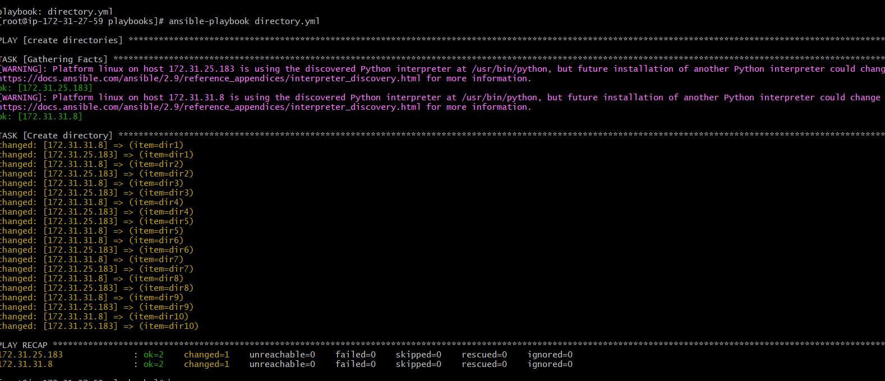



3) Ansible playbook to copy ssh-keygen from master to worker nodes.

Note: a)Provision new 3 ec2 machines, one master and two worker nodes.

Created 3 ec2 instances

b)Create common user called ansadm and provide sudo priviliges on 3 ec2 instances.

Create the User in all 3 servers

Useradd ansadm

Passwd ansadm

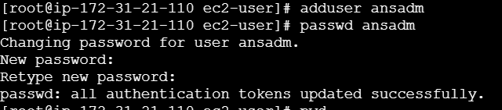

Add the User to the Sudoers File

echo "ansadm ALL=(ALL) NOPASSWD:ALL" | sudo tee -a /etc/sudoers

sudo mkdir -p /home/ansadm/.ssh

sudo chmod 700 /home/ansadm/.ssh

sudo chown ansadm:ansadm /home/ansadm/.ssh

c) Create ssh-keygen in master and you playbook should copy the keygen making it password less authentication.

4) Ansible playbook to inject ansible vault variables.

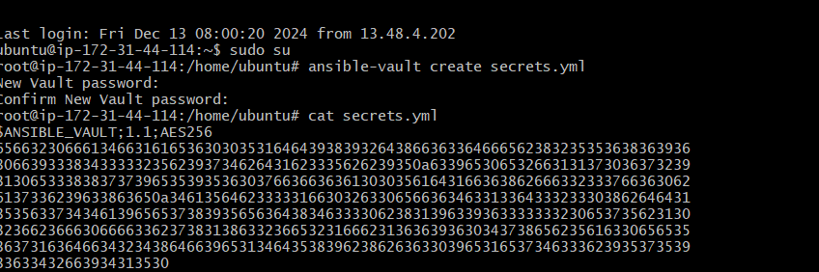

4) Ansible playbook to inject ansible vault variables.